TUGAS PRAKTIKUM

NAMA : DIKA ANDIYANI
NPM : 4513210015

- Tampil waktu sekarang
TampilWaktu.jsp
<%--
Document : tampilWaktu
Created on : Apr 8, 2016, 3:29:36 PM
Author : Dyka
--%>
<%@page import="java.sql.Time"%>
<%@page import="java.util.*"%>
<%@page contentType="text/html" pageEncoding="UTF-8"%>
<%@ page import="javax.servlet.*,java.text.*" %>
<%@ taglib prefix="x" uri="http://java.sun.com/jsp/jstl/xml" %>
<%@ taglib prefix="fn" uri="http://java.sun.com/jsp/jstl/functions" %>
<%@ taglib prefix="sql" uri="http://java.sun.com/jstl/sql_rt" %>
<%@ taglib prefix="c" uri="http://java.sun.com/jstl/core_rt" %>
<!DOCTYPE html>
<html>
<head>
<meta http-equiv="Content-Type" content="text/html; charset=UTF-8">
<title>Tampilan tanggal dan waktu sekarang</title>

<center>
<h1>Tanggal dan Waktu</h1>
</center>
<%
Date dNow = new Date( );
SimpleDateFormat dt = new SimpleDateFormat ("E yyyy.MM.dd ");
SimpleDateFormat ft = new SimpleDateFormat ("hh:mm:ss");
out.print( "<h2 align=\"center\">Hari dan tanggal saat ini " + dt.format(dNow) + "</h2>");
out.print( "<h2 align=\"center\">Waktu saat ini " + ft.format(dNow) + "</h2>");
%>



- Form input data dan tampilan simpanan data sementara nya
formInput.html
<!DOCTYPE html>
<!--
To change this license header, choose License Headers in Project Properties.
To change this template file, choose Tools | Templates
and open the template in the editor.
-->
<!DOCTYPE html>
<html>
<head>
<title>Form Buku</title>
<meta charset="windows-1252">
<meta name="viewport" content="width=device-width, initial-scale=1.0">
<meta http-equiv="Content-Type" content="text/html; charset=UTF-8">
</head>
<body>
<center>
<h1>Input Data</h1>
<form action="formInput" method="POST">

<table border='0'>

<tr>

<td>Nama</td>

<td>: <input name="nama" type="text" /></td>

</tr>
<td>Email</td>

<td>: <input name="email" type="text" /></td>

</tr>
<td>Tanggal Lahir</td>

<td>: <input name="tanggal_lahir" type="text" /></td>

</tr>
<td>Alamat</td>

<td>: <input name="alamat" type="text" /></td>

</tr>
<tr>

<td><input type="submit" name="send" value="Kirim" /></td>

<td><input type="reset" name="reset" value="Reset" /></td>

</tr>

</table>
</center>

</form>
</body>
</html>

formInput.jsp
/*
* To change this license header, choose License Headers in Project Properties.
* To change this template file, choose Tools | Templates
* and open the template in the editor.
*/

import java.io.IOException;
import java.io.PrintWriter;
import javax.servlet.ServletException;
import javax.servlet.annotation.WebServlet;
import javax.servlet.http.HttpServlet;
import javax.servlet.http.HttpServletRequest;
import javax.servlet.http.HttpServletResponse;

/**
*
* @author Dyka
*/
@WebServlet(urlPatterns = {"/formInput"})
public class formInput extends HttpServlet {

/**
* Processes requests for both HTTP <code>GET</code> and <code>POST</code>
* methods.
*
* @param request servlet request
* @param response servlet response
* @throws ServletException if a servlet-specific error occurs
* @throws IOException if an I/O error occurs
*/
protected void processRequest(HttpServletRequest request, HttpServletResponse response)
throws ServletException, IOException {
response.setContentType("text/html;charset=UTF-8");
String Nama = request.getParameter("nama");
String Email = request.getParameter("email");
String Tanggal_lahir = request.getParameter("tanggal_lahir");
String Alamat = request.getParameter("alamat");
PrintWriter out = response.getWriter();
try {
/* TODO output your page here. You may use following sample code. */
out.println("<!DOCTYPE html>");
out.println("<html>");
out.println("<head>");
out.println("<title>Tampil data Input</title>");
out.println("</head>");
out.println("<body>");
out.println("<center");
out.println("<h1>");
out.println("Verifikasi Data");
out.println("</h1>");
out.println("<table border='0'>");
out.println("<tr><td>Nama</td><td>: " + Nama + "</td></tr>");
out.println("<tr><td>Email</td><td>: " + Email + "</td></tr>");
out.println("<tr><td>Tanggal Lahir</td><td>: " + Tanggal_lahir + "</td></tr>");
out.println("<tr><td>Alamat</td><td>: " + Alamat + "</td></tr>");
out.println("</tr></table>");
out.println("</center");
out.println("</body>");
out.println("</html>");
} finally {
out.close();
}
}

// <editor-fold defaultstate="collapsed" desc="HttpServlet methods. Click on the + sign on the left to edit the code.">
/**
* Handles the HTTP <code>GET</code> method.
*
* @param request servlet request
* @param response servlet response
* @throws ServletException if a servlet-specific error occurs
* @throws IOException if an I/O error occurs
*/
@Override
protected void doGet(HttpServletRequest request, HttpServletResponse response)
throws ServletException, IOException {
processRequest(request, response);
}

/**
* Handles the HTTP <code>POST</code> method.
*
* @param request servlet request
* @param response servlet response
* @throws ServletException if a servlet-specific error occurs
* @throws IOException if an I/O error occurs
*/
@Override
protected void doPost(HttpServletRequest request, HttpServletResponse response)
throws ServletException, IOException {
processRequest(request, response);
}

/**
* Returns a short description of the servlet.
*
* @return a String containing servlet description
*/
@Override
public String getServletInfo() {
return "Short description";
}// </editor-fold>

}





Tampil data dari database JSTL + tampilan akhir
tampilWaktu.jsp
<%--
Document : tampilWaktu
Created on : Apr 8, 2016, 3:29:36 PM
Author : Dyka
--%>
<%@page import="java.sql.Time"%>
<%@page import="java.util.*"%>
<%@page contentType="text/html" pageEncoding="UTF-8"%>
<%@ page import="javax.servlet.*,java.text.*" %>
<%@ taglib prefix="x" uri="http://java.sun.com/jsp/jstl/xml" %>
<%@ taglib prefix="fn" uri="http://java.sun.com/jsp/jstl/functions" %>
<%@ taglib prefix="sql" uri="http://java.sun.com/jstl/sql_rt" %>
<%@ taglib prefix="c" uri="http://java.sun.com/jstl/core_rt" %>
<!DOCTYPE html>
<html>
<head>
<meta http-equiv="Content-Type" content="text/html; charset=UTF-8">
<title>Tampilan tanggal dan waktu sekarang</title>

<center>
<h1>Tanggal dan Waktu</h1>
</center>
<%
Date dNow = new Date( );
SimpleDateFormat dt = new SimpleDateFormat ("E yyyy.MM.dd ");
SimpleDateFormat ft = new SimpleDateFormat ("hh:mm:ss");
out.print( "<h2 align=\"center\">Hari dan tanggal saat ini " + dt.format(dNow) + "</h2>");
out.print( "<h2 align=\"center\">Waktu saat ini " + ft.format(dNow) + "</h2>");
%>

<h1>
Input Data Pada Form
</h1>
<p><a href="./formInput.html">Klik Disini</a></p>

<h2>DAFTAR PRODUK</h2>
<sql:setDataSource var="snapshot"
driver="com.mysql.jdbc.Driver"
url="jdbc:mysql://localhost/latihan_Prak2P4"
user="root" password=""/>

<sql:query dataSource="${snapshot}" var="result">
SELECT * FROM produk
</sql:query>

<table border="1" width="100%">
<tr>
<th>ID</th>
<th>Kode</th>
<th>Nama</th>
<th>Harga</th>
<th>Teakhir Update</th>
</tr>
<c:forEach var="row" items="${result.rows}">
<tr>
<td><c:out value="${row.id}"/></td>
<td><c:out value="${row.kode}"/></td>
<td><c:out value="${row.nama}"/></td>
<td>Rp. <c:out value="${row.harga}"/></td>
<td><c:out value="${row.terakhir_update}"/></td>
</tr>
</c:forEach>
</table>

</head>

</html>

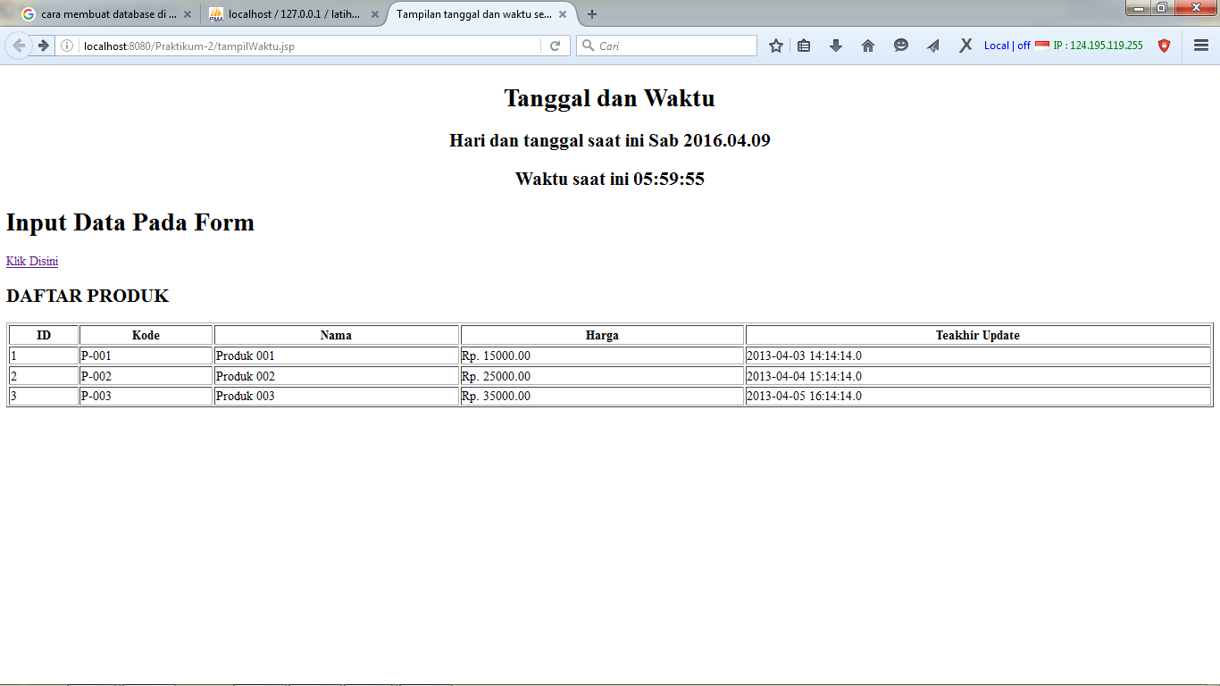
Deployment
cd D:\Dyka KULIAH\6\Pemrograman-4\Praktikum2; "JAVA_HOME=C:\\Program Files (x86)\\Java\\jdk1.8.0_20" cmd /c "\"\"C:\\Program Files (x86)\\NetBeans 8.0.2\\java\\maven\\bin\\mvn.bat\" -Dnetbeans.deploy=true -Dnetbeans.deploy.clientUrlPart=/tampilWaktu.jsp -Dmaven.ext.class.path=\"C:\\Program Files (x86)\\NetBeans 8.0.2\\java\\maven-nblib\\netbeans-eventspy.jar\" -Dfile.encoding=UTF-8 package\""
Scanning for projects...

------------------------------------------------------------------------
Building Praktikum2 1.0-SNAPSHOT
------------------------------------------------------------------------

--- maven-dependency-plugin:2.6:copy (default) @ Praktikum2 ---

--- maven-resources-plugin:2.5:resources (default-resources) @ Praktikum2 ---
[debug] execute contextualize
Using 'UTF-8' encoding to copy filtered resources.
Copying 0 resource

--- maven-compiler-plugin:3.1:compile (default-compile) @ Praktikum2 ---
Nothing to compile - all classes are up to date

--- maven-resources-plugin:2.5:testResources (default-testResources) @ Praktikum2 ---
[debug] execute contextualize
Using 'UTF-8' encoding to copy filtered resources.
skip non existing resourceDirectory D:\Dyka KULIAH\6\Pemrograman-4\Praktikum2\src\test\resources

--- maven-compiler-plugin:3.1:testCompile (default-testCompile) @ Praktikum2 ---
No sources to compile

--- maven-surefire-plugin:2.10:test (default-test) @ Praktikum2 ---
Surefire report directory: D:\Dyka KULIAH\6\Pemrograman-4\Praktikum2\target\surefire-reports

-------------------------------------------------------
T E S T S
-------------------------------------------------------

Results :

Tests run: 0, Failures: 0, Errors: 0, Skipped: 0

--- maven-war-plugin:2.3:war (default-war) @ Praktikum2 ---
Packaging webapp
Assembling webapp [Praktikum2] in [D:\Dyka KULIAH\6\Pemrograman-4\Praktikum2-1.0-SNAPSHOT]
Processing war project
Copying webapp resources [D:\Dyka KULIAH\6\Pemrograman-4\Praktikum2\src\main\webapp]
Webapp assembled in [39 msecs]
Building war: D D:\Dyka KULIAH\6\Pemrograman-4\Praktikum2-SNAPSHOT.war
------------------------------------------------------------------------
BUILD SUCCESS
------------------------------------------------------------------------
Total time: 2.179s
Finished at: Sat Apr 09 17:59:53 ICT 2016
Final Memory: 9M/21M
------------------------------------------------------------------------
NetBeans: Deploying on GlassFish Server 4.1
profile mode: false
debug mode: false
force redeploy: true
Undeploying ...
In-place deployment at D:\Dyka KULIAH\6\Pemrograman-4\Praktikum2\target\Praktikum2-1.0-SNAPSHOT

